NAAN MUDHALVAN

NAME:Elamathi

COURSE:SALESFORCE

NM ID: 9AF59DC630E1A8DA02E48E7B7F63FCC0

Task1:

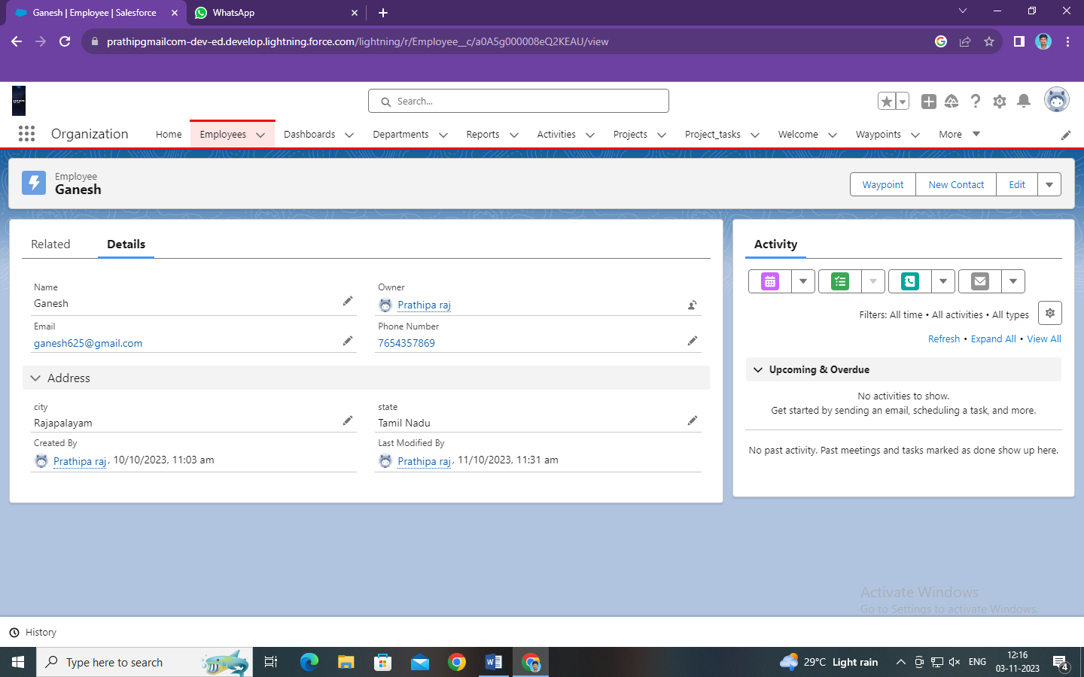

Task 2:

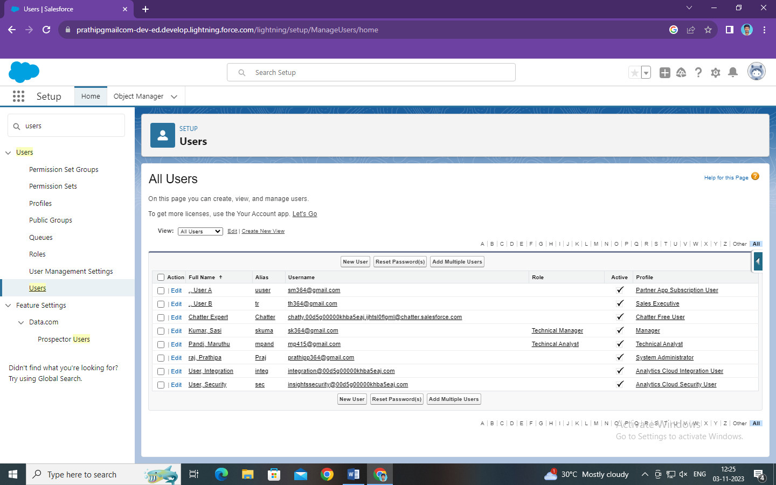

Task 3:

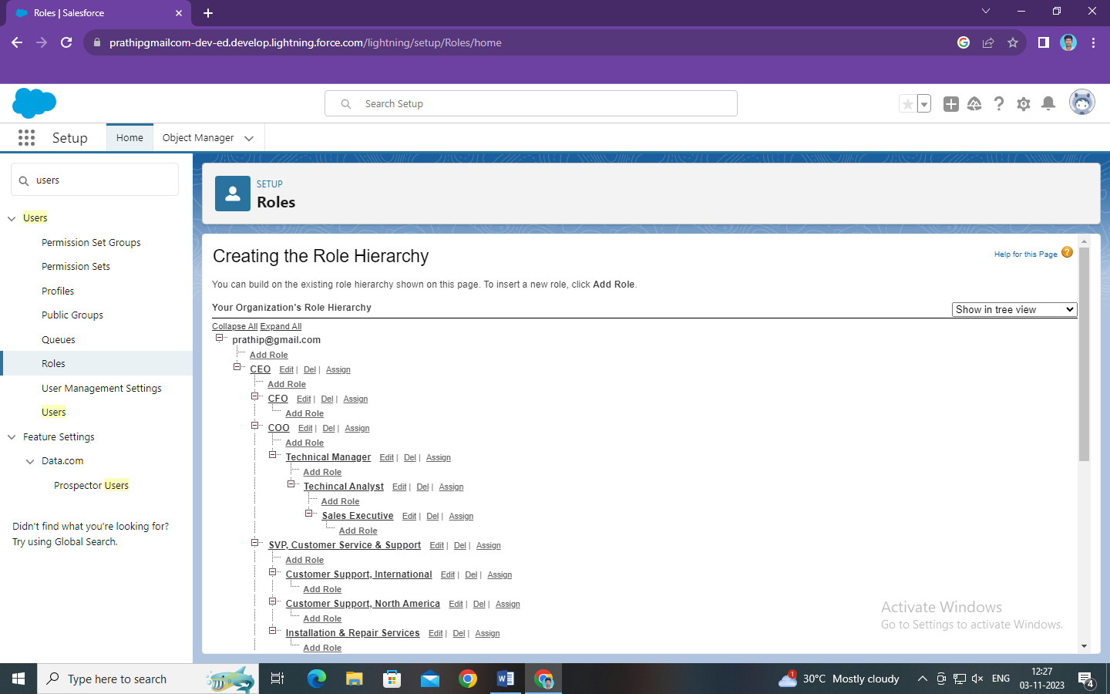

Task 4:

